COVID-19
We are ready to receive business & leisure travelers at Tsauchab River Camp and A Little Sossus Lodge in a phased response to travel demand as Namibia moves to Level 1 alert of the lockdown.
The COVID-19 protocol that we have put in place in both our operating properties, A Little Sossus Lodge and Tsauchab River Camp is for the safety and reassurance of staff and guests. This protocol is outlined below, followed by the business & leisure lodge protocols.
The COVID-19 protocol includes but is not limited to:
Screening of guests on arrival in order to prevent an infected person from checking into the hotel. Guests are required to:
• complete and sign a questionnaire
• allow their temperature to be scanned with a thermal scanner
If a guest’s temperature falls within the normal range and they do not show any symptoms they will be required to sanitise their hands and proceed to check-in.
If a guest’s temperature is high (actual temperature at screening should not exceed 37.5 degrees Celsius) and/or they have symptoms of the virus they will be disallowed to check-in and will be referred to a medical facility.
Educating staff (ongoing) on what the virus is; where the disease outbreak began; ways in which it is transmitted; symptoms to look out for; and daily measures to prevent contamination and spread of viruses in personal, operational and guest spaces.
Staff hand sanitisers (alcohol based) have been rolled out in back of house areas (such as kitchen, office, laundry, staff restaurant and bathrooms) as well as front of house guest areas (such as reception desk, bar, restaurant, lounge, fitness room, boardroom and meeting room).
Guest hand sanitisers (alcohol based) are placed in easy reach of guests in public areas of the hotel with a notice encouraging regular use.
Personal hygiene is being reiterated, including the importance of washing hands frequently and thoroughly; avoiding touching eyes, nose and mouth; practicing respiratory hygiene (sneezing and coughing into a tissue that is safely discarded or the crook of the elbow), and avoiding touching one’s face;
Regular routine cleaning of public areas such as restrooms, breakfast rooms, restaurants, table tops, counters, hand rails, door knobs, back office surfaces and front desk surfaces are wiped down on a regular routine throughout the day, with a polycide chemical (a disinfectant cleaner) that kills most viruses;
Sanitisers for security officers at our lodge entrances have also been issued to ensure hygiene for themselves as well as all our arriving guests.
Protective wear such as protective gloves, aprons and face masks are issued to housekeeping and public area Guest Service Attendants when on duty and cleaning equipment with a polycide chemical (disinfectant cleaner) between guest and rest rooms.
Avoiding close contact with anyone who is coughing, sneezing and feverish. Anyone showing symptoms of respiratory illness to be reported to the hotel’s general manager for further action to take place, such as contacting the hotline.
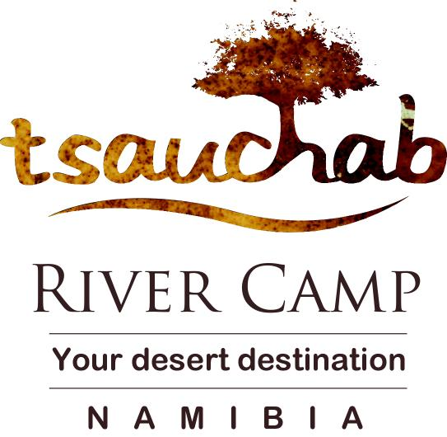
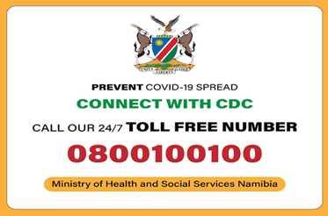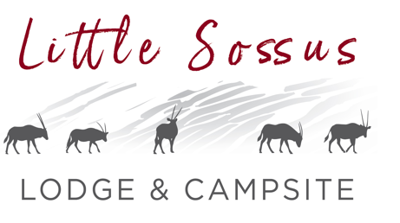

Breakfast serving standards have been reviewed to replace the usual buffet with a la carte breakfast options presented to guests to avoid any instances of buffet contamination.
The CDC Hotline is available to all staff and guests. In the event that anyone feels ill after travelling from countries with coronavirus, the Ministry of Health & Social Services in Namibia advises first phoning the Centers for Disease Control and Prevention
(CDC) helpline rather than going straight to a medical facility, to prevent potential contamination. The CDC hotline number is 0800100100.
While no one can predict the path of this virus, we are continuously monitoring developments and doing all we can to reduce the risk of potential contamination or spread of disease. We thank you for choosing to stay at A Little Sossus Lodge (ALS) & Tsauchab River Camp (TRC) property and look forward to delivering on our service excellence promise.

